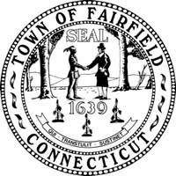
WHY IS THE TOWN SEAL UPSIDE DOWN?
An upside down flag is a universal signal of distress.

Fairfield is in distress because it is becoming unaffordable.
Everyone agrees that spending for schools and municipal services (like policemen, firemen, roads, bridges, beaches and parks) is a good thing because it makes Fairfield a great place to live and supports strong property values.
However, as with most things in life (e.g., sun, rain, ice cream, soft drinks and beer), we can also have too much of a good thing. At some point, spending and taxes become too high and unsustainable.
Getting the balance right is not easy, particularly when the long-term effects are not obvious. Like erosion from wind, rain and footsteps, the cumulative effects of a long series of small budget steps can be surprisingly large and sometimes irreversible.
Fairfield Taxpayer is a new, non-partisan organization dedicated to KEEPING FAIRFIELD AFFORDABLE.
Before you get distracted, please make a mental note to visit us at www.fairfieldtaxpayer.com to become better informed and, we hope, to add your voice to our online discussions.

Join the 250 people who in February alone “Liked” us on Facebook.
PLEASE: SIGN UP, BE HEARD, MAKE A DIFFERENCE!

Four Basic Questions:
Question #1: “Is Fairfield in distress?”
Answer: Fairfield is becoming unaffordable relative to other communities with comparable services.
- Fairfield has been increasing its spending much faster than the rate of inflation for many years.

Cumulative Percentage Growth 1998/99 to 2013/14
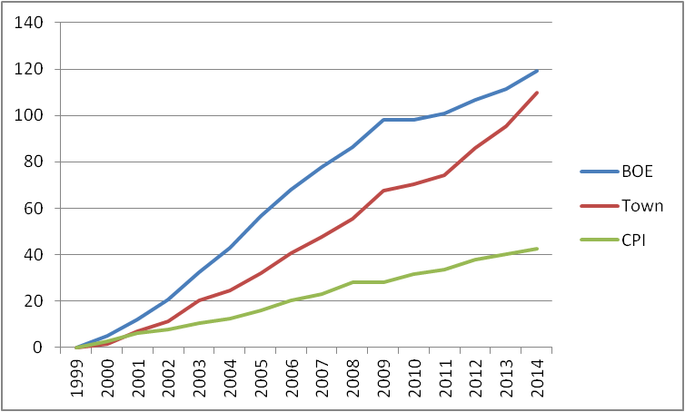
- Fairfield’s tax rates are now 31%, 84%% and 125% higher than towns like Westport, Darien and Greenwich.
Taxes on Homes Valued at $500,000, $750,000 and $1,000,000
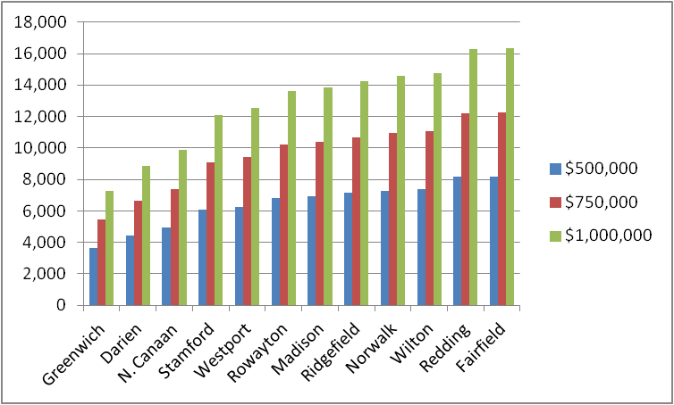
- The school administration claims that education spending per student is reasonable relative to certain other southern Fairfield County communities, but relative to our capacity to spend, we are spending substantially more than most of those towns , including Greenwich, New Canaan, Darien, Westport, Wilton, Weston and Stamford.
Local, Residential Education Spending as a Percent of Wealth
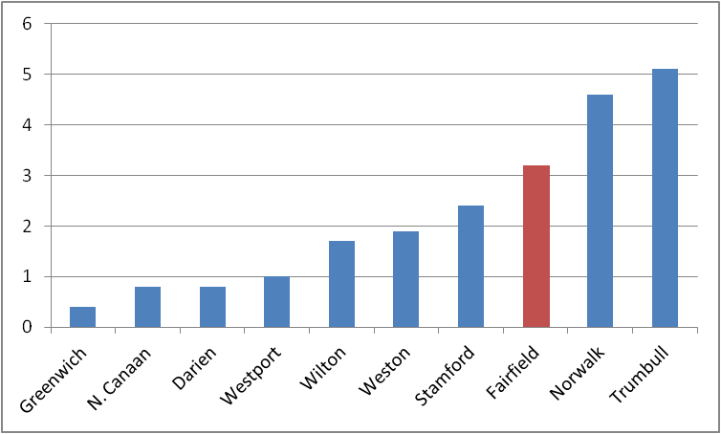

- The First Selectman has proposed a budget for 2013-2014 that would require a 6.4% increase in the “mill rate,” which means that property taxes would rise more than three times the rate of general price level inflation in the economy. It would also mean a 25% increase in total spending since 2008, the year before the Great Recession. How many Fairfield residents have enjoyed a 25% increase in their disposable income since 2008?

- Home prices in Fairfield – all home prices: lower end, higher end and middle – are being hurt by our high taxes; more and more people are being forced to sell their homes and move away, particularly seniors living on fixed incomes.
Question #2: “Who is responsible for allowing spending and taxes to get out of balance?”
Answer: Ultimately, we are all responsible because without considering the long-term consequences:
- We supported higher spending while we had children in school or when a particular town service benefited our family or our neighborhood.
- We were too busy to worry about town budgets and taxes, so we paid little attention to them.
- We didn’t have time to study hundreds of pages of budget papers filled with thousands of numbers and arcane terms, or to attend the many long meetings of various town bodies.
- We doubted that one person could accomplish much by writing letters to public officials or to local news media, or by joining a long line at a town meeting and speaking for the two minutes we are allowed to comment.
- We believed that “You Can’t Fight Town Hall.”
- We figured that if things got really bad, we would simply move away.
Question #3: “Why don’t our elected representatives do something about it?”
Answer: Our local governance system is broken and our elected representatives are only human.
- When our governance system was created, Fairfield was an agrarian community where most people expected to spend their entire lives and pass their properties down to their children to do the same; everyone had a strong, natural sense of “ownership” in and responsibility for the long-term best interests of “Our Town.“
- The “social compact” of contributing to shared benefits like roads, bridges, public safety and schools extended across generations, and every household benefited directly from them and expected their children and grandchildren to do so.
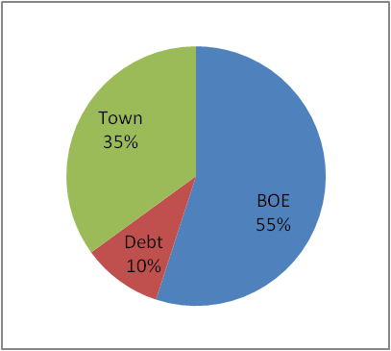
- Almost 275 years later, for better and for worse, we live in a highly mobile society in which anyone who lives their entire life in one town is now the exception, and towns like Fairfield must compete with other towns to attract and retain residents who are willing to pay for services they don’t use, particularly our excellent public schools, which are used by only 30% of Fairfield households and account for ~55% of total public spending.
- The well meaning, dedicated people who represent us on town bodies are only human. Even though most of them are paid nothing for the long hours they put in on our behalf, they seem to enjoy public office enough to want to be reelected; they also don’t want a lot of aggravation from unhappy friends and neighbors about the decisions they make.
- Getting re-elected in municipal elections means pleasing the ~40% of voters who turn out, and it is generally much easier to get votes (and avoid aggravation) by giving people more things (i.e., spending more) than it is by taking things away (i.e., spending less).
- The median home with a market value of $550,000 pays about $9,000 in tax deductible taxes. So the 30% of Fairfield households with children in our public schools get a great deal because the town pays $15,000 to educate each of their kids. Thus, it is not surprising that people who turn out for municipal elections include a disproportionate number of parents with children in our public schools.
- Encouraged by well organized groups like the PTAs, not only do parents get out and vote, but they are also highly vocal at public meetings in support of more spending on education, with recurring slogans like, “the children are our future,” and “great schools support property values.”
- There is no organization comparable to the PTAs and Teachers Union urging the other 70% of Fairfield households (a.k.a., The Silent Majority) to speak out and vote.
- With only 40% turnout, it is easy for a minority (the 30%) to become a majority.
Question #4: “So what can we do?”
Answer: We can convert the Silent Majority into a Vocal Majority.
- The Silent Majority is silent only by choice.
- We can speak up.
- We can vote in municipal elections.
- We can invoke our right to challenge decisions made by our town bodies using the public referendum process.
The Singular Objective of Fairfield Taxpayer is to:
“Keep Fairfield Affordable.”
Some specific proposals that will help to keep Fairfield affordable:
- All of our elected representatives must acknowledge the seriousness of our current tax problem and seek a 2014 budget with no increase or a decline in spending despite “unavoidable” increases in certain contractual costs;
- All town bodies should be required to explain the basis upon which they have concluded that any budget they approve is affordable for the taxpayers of Fairfield;
- Fairfield needs a long-term, fiscally responsible strategic plan that, among other things, addresses the need for more non-residential commercial development in order to ease the burden on residential property owners;
- The school and town administrations should provide budget breakdowns by service so that the people and their elected representatives can make informed decisions about which services they want and can afford from their government;
- All public employee benefits should be changed to be competitive with, rather than superior to, those in the private sector;
- The First Selectman must provide strong leadership on the issue of affordability; which does not mean making excuses for bad outcomes and offering assurances that future outcomes will be better as long as there are no new challenges that provide new excuses; and
- Our State Representatives must provide strong leadership on the issue of unfunded state mandates that increase our local property taxes, such as Binding Arbitration, Minimum Budget Requirements and Prevailing Wages.
Fairfield Taxpayer welcomes additional ideas, insights and suggestions from you.
___________________
Additional and supporting information for the statistics and graphs in this ad can be found at www.fairfieldtaxpayer.com.

